NASSPD 2022 – Author Instructions for the Microsoft CMT System
- Step 1:
  - If you do not already have a Microsoft CMT account, please click on the following link to sign up for a new account: https://cmt3.research.microsoft.com/User/Register?ReturnUrl=%2F.
This link should take you to the page displayed in the screenshot below. Please fill in all required information to create a new account. An institutional email address (e.g., university, college or hospital email address) is preferred. (Please note: including your Google Scholar ID is not necessary.)
  - If you already have a Microsoft CMT account, please proceed to Step 3 below.

- Step 2: You will receive an email from Microsoft CMT with a request for account verification. Follow the link provided in the email to verify your account. You will be brought to a webpage confirming your account verification. Click on the word “here” (as pictured below), log into your account, and then close this webpage.
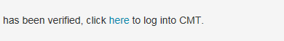

- Step 3: Visit the following website: https://cmt3.research.microsoft.com/NASSPD2022 and enter your email and password to log in to the Microsoft CMT system. In the event that you have forgotten your password, click on “Reset your password” and instructions to do so will be emailed to you.
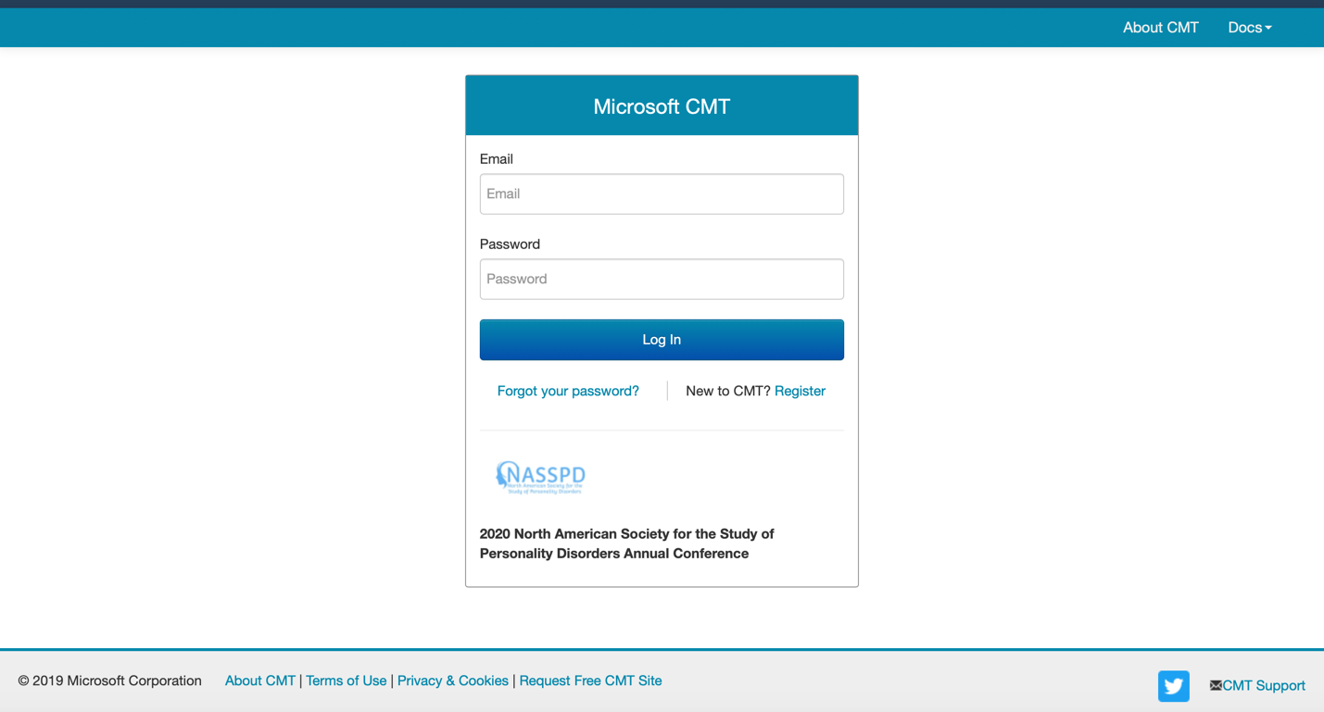

- Step 4: To create a submission for NASSPD 2020, click “Create new submission” (as circled in red below).

- Step 5: Once you have clicked the “Create new submission” button, you will be taken to
the page as displayed in the screenshot below. Please review the submission requirements described at the top of the page before proceeding with your submission.

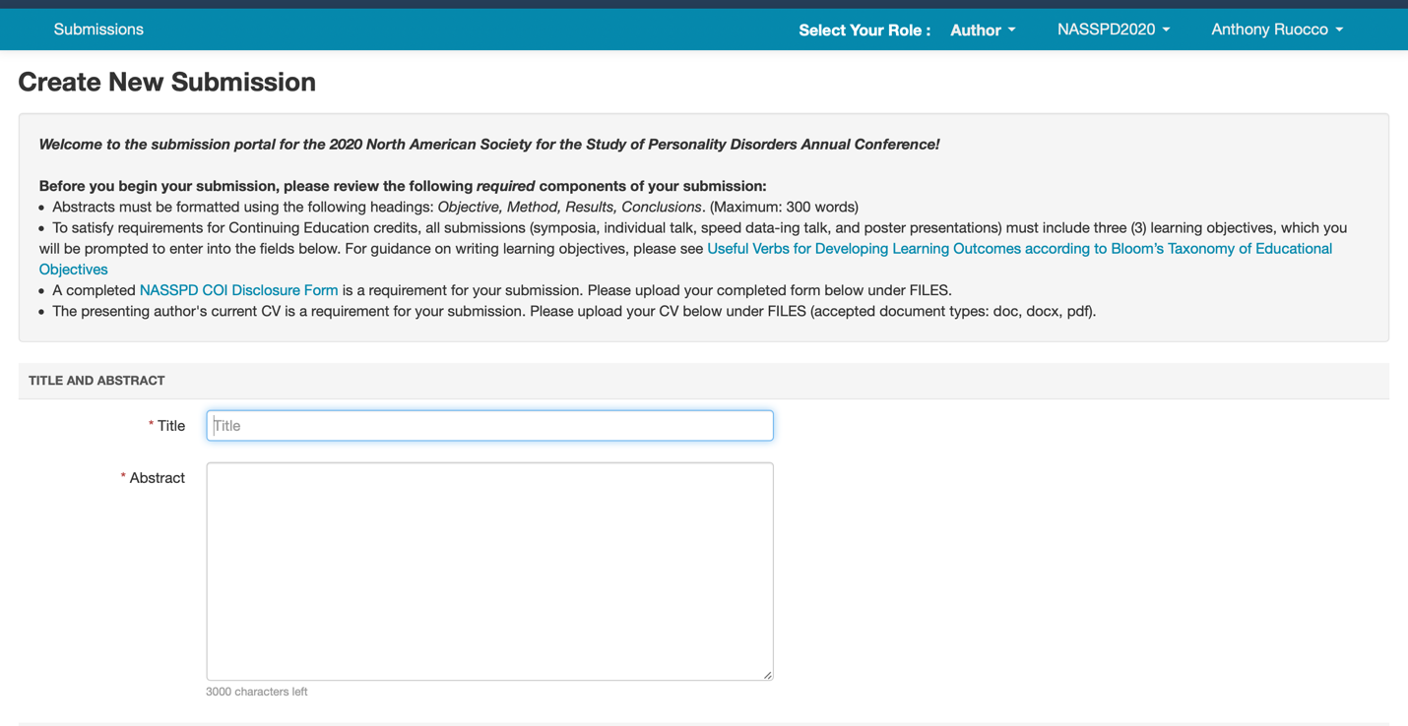

- Step 6: Fill in the relevant fields in the form. Note that authors can be added to your submission by adding their email addresses (as shown below).

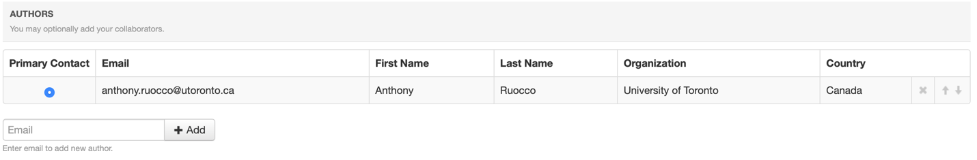

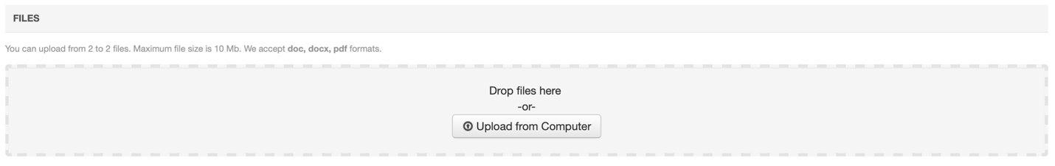
- Step 7: Be sure to upload the required files by either clicking “Upload from computer” (circled in red in the screenshot below), or by dragging and dropping your files onto the labeled area. You can upload up to 2 files (doc, docx and pdf formats are acceptable). The maximum file size that can be uploaded is 10Mb.

Step 8: After you have completed all relevant fields, please click “Submit” at the bottom of the page. You will be taken to a page where you will be asked to indicate whether you have a conflict of interest with any of the currently listed Reviewers. If you have a conflict, use the edit box to select the type of conflict(s). The options are as follows:
  - a co-author
  - is/was a colleague (in the last 2 years)
  - is/was a collaborator (in the last 2 years)
  - or I, is/was a Primary Thesis Advisor at anytime
  - is a Relative or a friend
If you have no conflicts of interest to report with the Reviewers, do not make a selection.
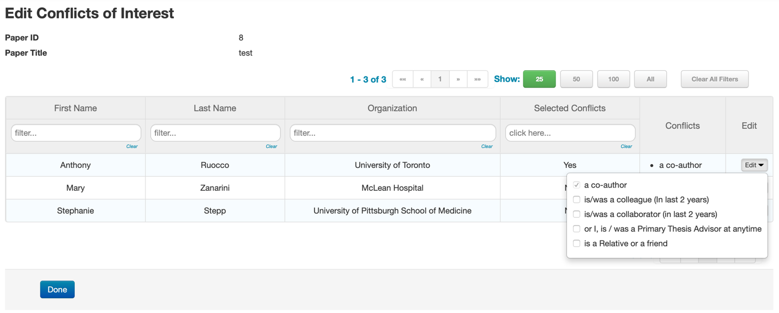
When you have finished reporting any conflicts of interest, please select Done.

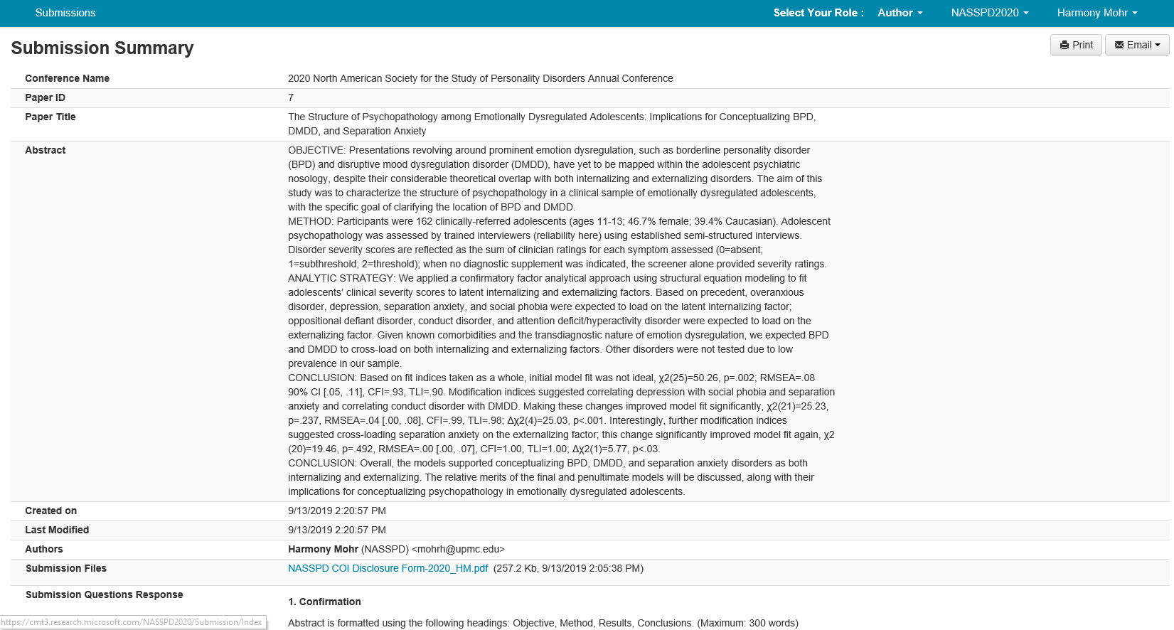
- Step 9: Once you have selected “Done”, you will be taken to a page that displays a summary of your submission.

If you would like to make edits to your submission, you may do so before the abstract submission deadline (see NASSPD website for the relevant deadline). If you would like to start another submission, you may do so by returning to Step 4 and following the instructions to create a new submission.

